**Software Requirement Specification Document for “SALMANS”**

**Team members:**

*Chinedu Urbanus Ugwu - 610119*

*John Imhonikhe Lawal - 610098*

*Mohammed Seud - 109362*

**GitHub Link For The Project**: <https://github.com/JohnLawal/SALMANS>

**USE CASE MODEL**

**Use Case Diagrams**

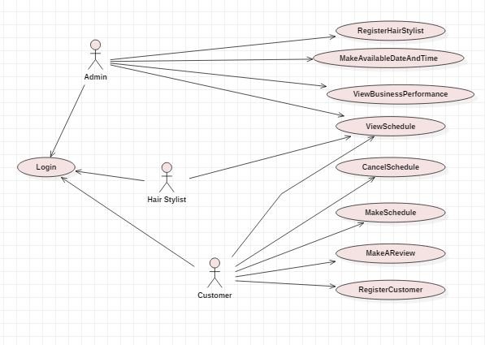

**Use Case Descriptions**

|  |  |  |
| --- | --- | --- |
| **Use Case Number:** 1 | | |
| **Name:** Registering A NewHair Stylist | | |
| **Brief description:** This use case allows the admin to create profiles for hair stylists | | |
| **Actors:** Admin | | |
|  | | |
| **Preconditions** | | |
| The admin must be logged in to the system | | |
| **Flows of Events:** | | |
| **1. Basic Flows:** | | |
| **1.1.0 Create Hair Stylist Profile** | | |
| **Step** | **User Actions** | **System Actions** |
| 1 | The admin calls the create hairstylist profile command | The system displays the hairstylist profile form with the fields for full name, email, and password and seat number. |
| 2 | The admin fills out the form and requests the system to save the details. | The system verifies that there’s no other profile in the database with the same email address and saves the hairstylist and returns the success message on success or a fail message in case of failure. In case another profile exists with the email address, the system returns the message indicating a duplicate entry exists. |
| **Post conditions** | | |
| The hairstylist profile is persisted in the system | | |
|  | | |
| **Business Rules** | | |
| No duplicate hair stylist profiles. A unique profile is identified by email address.  The seat number must not be assigned to another hairstylist already. | | |
|  | | |
| **Use Case Number:** 2 | | |
| **Name:** Registering A NewCustomer | | |
| **Brief description:** This use case allows the customers to create profiles for themselves. | | |
| **Actors:** Customer | | |
|  | | |
| **Flows of Events:** | | |
| **1. Basic Flows:** | | |
| **1.1.0 Create Customer Profile** | | |
| **Step** | **User Actions** | **System Actions** |
| 1 | The customer calls the create profile command | The system displays the customer profile form with the fields for full name, email, and password. |
| 2 | The customer fills out the form and requests the system to save the details. | The system verifies that there’s no other profile in the database with the same email address and saves the customer and returns the success message on success or a fail message in case of failure. In case another profile exists with the email address, the system returns the message indicating a duplicate entry exists. |
| **Post conditions** | | |
| The customer profile is persisted in the system | | |
|  | | |
| **Business Rules** | | |
| No duplicate customer profiles. A unique profile is identified by email address. | | |
|  | | |
| **Use Case Number:** 3 | | |
| **Name:** Customer Makes Schedule | | |
| **Brief description:** This use case allows the customers to schedule appointments. | | |
| **Actors:** Customer | | |
|  | | |
| **Preconditions** | | |
| The customer must be logged in to the system | | |
| **1. Basic Flows:** | | |
| **1.1.0 Make Schedule** | | |
| **Step** | **User Actions** | **System Actions** |
| 1 | The customer calls the make schedule command | The system displays the list of available dates and times with open seats. |
| 2 | The customer selects an available date and submits | The system verifies that the date is available and displays a screen for the user to select or provide their style and choose a seat number. |
| 3 | The customer selects or provides their desired style and seat number and submits. | The system verifies that the seat number is available and proceeds to save the customers selection. |
| **Post conditions** | | |
| The customer's schedule is persisted in the system.  An email confirmation is sent to the customer.  The date and seat is now made unavailable for further selection. | | |
|  | | |
| **Business Rules** | | |
| No duplicate assigning of seats, dates and times. | | |
|  | | |
| **Use Case Number:** 4 | | |
| **Name:** Customer Cancels Schedule | | |
| **Brief description:** This use case allows the customers to schedule appointments. | | |
| **Actors:** Customer | | |
|  | | |
| **Preconditions** | | |
| The customer must be logged in to the system.  The customer must have an existing appointment/schedule. | | |
| **1. Basic Flows:** | | |
| **1.1.0 Make Schedule** | | |
| **Step** | **User Actions** | **System Actions** |
| 1 | The customer calls the cancel schedule command | The system verifies that the customer has a schedule and cancels the schedule |
| **Post Conditions** | | |
| The customer's schedule is updated in the system.  An email confirmation is sent to the customer.  The date and seat is now made available for selection. | | |
|  | | |
| **Business Rules** | | |
| No cancelling of schedules that do not exist. | | |
|  | | |
| **Use Case Number:** 5 | | |
| **Name:** View Schedule | | |
| **Brief description:** This use case allows the customers to view their personal schedule. It allows hairstylists view their assigned schedules. It allows the admin view all assigned schedules. | | |
| **Actors:** Customer, Hair Stylists, Admin | | |
|  | | |
| **Preconditions** | | |
| The actor must be logged in to the system. | | |
| **1. Basic Flows:** | | |
| **1.1.0 Customer View Schedule** | | |
| **Step** | **User Actions** | **System Actions** |
| 1 | The customer calls the view schedule command | The system retrieves the schedules and details for this member only and displays it on the screen. |
| **1.1.1 Hair Stylist View Schedule** | | |
| **Step** | **User Actions** | **System Actions** |
| 1 | The hairstylist calls the view schedule command | The system retrieves the schedules assigned to this hairstylist only and displays it on the screen. |
| **1.1.1 Admin View Schedules** | | |
| **Step** | **User Actions** | **System Actions** |
| 1 | The admin calls the view schedules command | The system retrieves appointed schedules and displays it on the screen. |
|  | | |
| **Use Case Number:** 6 | | |
| **Name:** View Business Performance | | |
| **Brief description:** This use case allows the admin to view summary information about his business. | | |
| **Actors:** Admin | | |
|  | | |
| **Preconditions** | | |
| The admin must be logged in to the system. | | |
| **1. Basic Flows:** | | |
| **1.1.0 View Customer Reviews** | | |
| **Step** | **User Actions** | **System Actions** |
| 1 | The admin calls the view customer reviews command. | The system retrieves current customer reviews and displays them on the screen. |
| **1.1.1 View Summary Information** | | |
| **Step** | **User Actions** | **System Actions** |
| 1 | The admin calls the view summary information command. | The system retrieves summary information and displays them on the screen. |
|  | | |
| **Use Case Number:** 7 | | |
| **Name:** Make Available Date And Time | | |
| **Brief description:** This use case allows the admin to specify business hours and available dates. | | |
| **Actors:** Admin | | |
|  | | |
| **Preconditions** | | |
| The admin must be logged in to the system. | | |
| **1. Basic Flows:** | | |
| **1.1.0 Enter Available Dates and Time** | | |
| **Step** | **User Actions** | **System Actions** |
| 1 | The admin calls the make available business hours command. | The system displays the form for specifying available dates and times on the screen. |
| 2 | The admin enters the available dates and times and submits the form. | The system stores the information in the database |
| **Post Conditions** | | |
| The dates are now displayed as available and customers can select those dates for appointment. | | |

**SUPPLEMENTARY SPECIFICATION**

The system will fulfil several non-functional requirements including:

**Scalability –** The application will scale to accommodate any number of users as customers or hairstylists are registered.

**Security –** The application will ensure that details of the entire users are secure and free from external manipulation.

**User Friendliness –** The application will be developed in a way that it will be easily usable by its users.

**Performance –** The application will be developed to perform optimally.

**Availability –** The application will be able available for 99.9% of the time.

**GLOSSARY**

**Hairstylist -** is a person whose occupation is to cut or style hair in order to change or maintain a person's image.

**Schedule** - a timetable for carrying hairstyling in the, stating date and time.